Basic react app

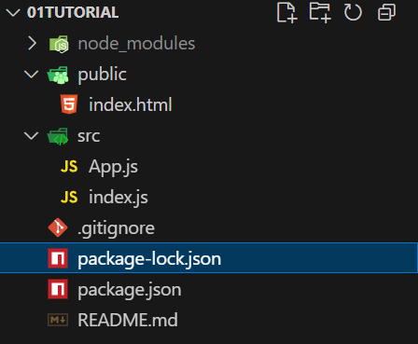

Vite doesn’t allow js for component

Have to use jsx

It is allowed in create-react-app only 🡪 js and jsx extension are same

INTERVIEW QUESTION

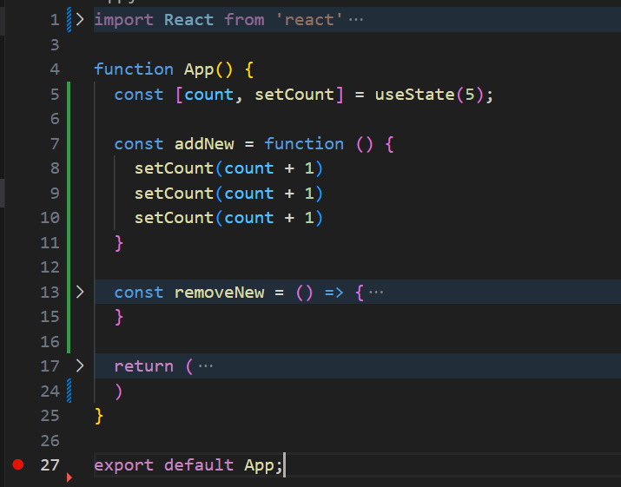

If a function have 4 or 5 increments like this, will it increment all 5 or just 1-increment.???

**Ans:- It just increment by 1, as useState renders the data in the form of bunch. (**so it take all as 1**)**

To use it as expected, we can pass a call-back function inside it. {setCount fn is able to accept argument}

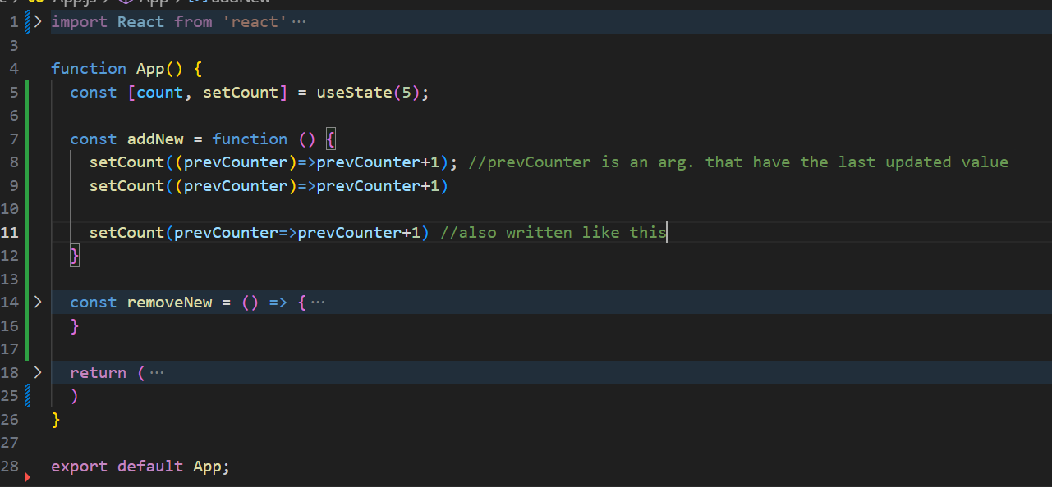

prevCounter is just a variable_name.

ONCLICK function :

It can take a function as a argument, but it doesn’t require the returned values of a function

 here it is a function call as we use (), so it receive the returned value.

 here, It is a function / function reference here.

But if we want to sent a argument inside the function, we have to use call-back

